WORLD BILLIARD-HOCKEY & MULTITABLE CHAMPIONSHIP 2008

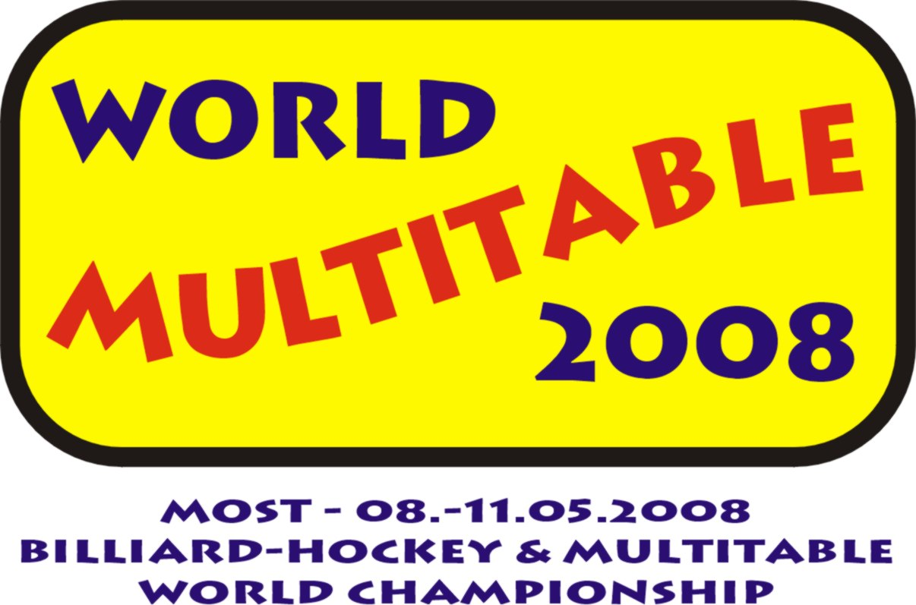

RESULTS SUMMARY – DAY I (May 8, 2008)

Ladies

Rod-hockey Luch (world championship & part of multitable)
1. VANOVA Lucie CZECH REPUBLIC
2. ZAUANA Magdalena NAMIBIA
3. VELEBOVA Nikola CZECH REPUBLIC

Rod-hockey Chemoplast (world championship & part of multitable)
1. VELEBOVA Nikola CZECH REPUBLIC
2. VANOVA Lucie CZECH REPUBLIC
3. REDLOVA Tereza CZECH REPUBLIC

Rod-hockey Stiga (part of multitable)
1. VELEBOVA Nikola CZECH REPUBLIC

Air-hockey (WTHA European championship & part of multitable)
1. VELEBOVA Nikola CZECH REPUBLIC
2. TRUHLAROVA Veronika CZECH REPUBLIC
3. BARTOSKOVA Ywetta CZECH REPUBLIC

Multitable leader after Day I
VELEBOVA Nikola CZECH REPUBLIC
Men

Rod-hockey Luch (world championship & part of multitable)
1. GRISHIN Sergey RUSSIA
2. EKLUND Micke SWEDEN
3. TOMASHPOL Semeon RUSSIA

Rod-hockey Chemoplast (world championship & part of multitable)
1. TRUHLAR Vaclav CZECH REPUBLIC
2. GRISHIN Sergey RUSSIA
3. TOMASHPOL Semeon RUSSIA

Rod-hockey Stiga (part of multitable)
1. GRISHIN Sergey RUSSIA

Air-hockey (WTHA European championship & part of multitable)
1. KUCERA Martin CZECH REPUBLIC
2. HONSA Petr CZECH REPUBLIC
3. KYZLINK Dalibor CZECH REPUBLIC

Multitable leader after Day I
EKLUND Micke SWEDEN
Juniors U 18

Rod-hockey Luch (world championship & part of multitable)
1. LE Michal CZECH REPUBLIC
2. JEZEK Jiri CZECH REPUBLIC
3. ZHRIVAL Jaromir CZECH REPUBLIC

Rod-hockey Chemoplast (world championship & part of multitable)
1. JEZEK Jiri CZECH REPUBLIC
2. MYKHAYLYSHYN Bohdan UKRAINE
3. KRISTIANSSON Patrik SWEDEN

Rod-hockey Stiga (part of multitable)
1. KRISTIANSSON Patrik SWEDEN

Air-hockey (WTHA European championship & part of multitable)
1. FALTYNEK Max CZECH REPUBLIC
2. ZHRIVAL Jaromir CZECH REPUBLIC
3. FLEISMAN Tomas CZECH REPUBLIC

Multitable leader after Day I
KRISTIANSSON Patrik SWEDEN

Associated tournament

Billiard-hockey (WTHA Tour - Challenger)
1. TIHELKA Robert CZECH REPUBLIC
2. ERIKSSON-MENCL Joan SWEDEN
3. KOLODEJ Pavel CZECH REPUBLIC

Mistrovství světa 2008 – http://www.multitable2008.com

HLAVNÍ PARTNER MS 2008



PARTNEŘI MS 2008

