WORLD BILLIARD-HOCKEY & MULTITABLE CHAMPIONSHIP 2008

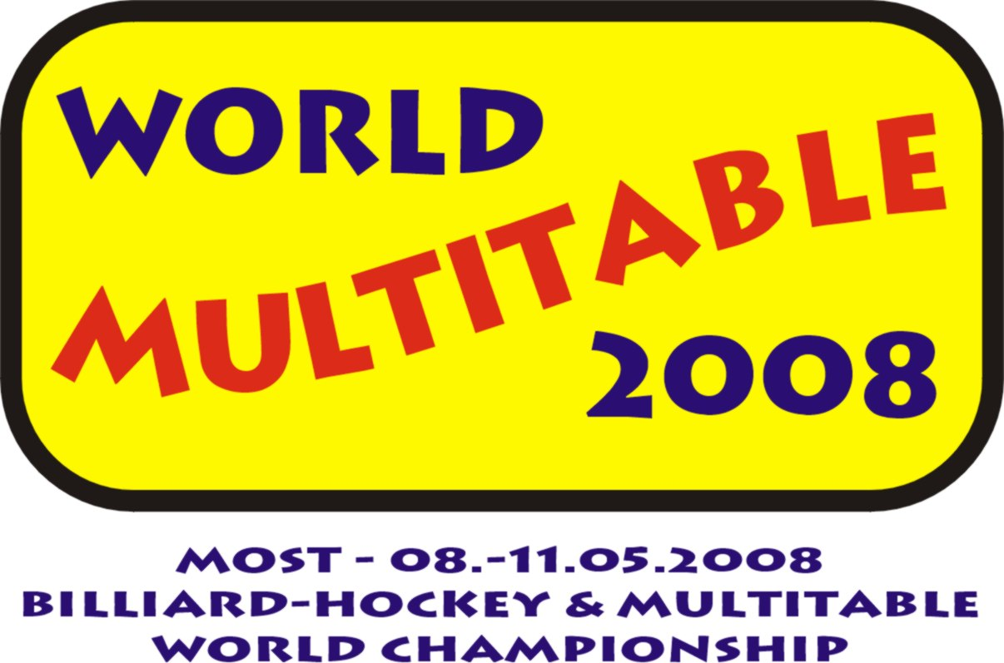

RESULTS SUMMARY – DAY II (May 9, 2008)

Ladies

Billiard-hockey (world championship & part of multitable)
1. VELEBOVA Nikola CZECH REPUBLIC
2. MATLOVA Petra CZECH REPUBLIC
3. KABRDOVA Marcela CZECH REPUBLIC

Multitable leader after Day II
VELEBOVA Nikola CZECH REPUBLIC
Men

Billiard-hockey (world championship & part of multitable)
1. KUCERA Martin CZECH REPUBLIC
2. TICHAVSKY Ales CZECH REPUBLIC
3. HONSA Petr CZECH REPUBLIC
Multitable leader after Day II
HONSA Petr CZECH REPUBLIC
Juniors U 18

Billiard-hockey (world championship & part of multitable)
1. TUMA Vaclav Jun. CZECH REPUBLIC
2. KOLODEJ Pavel CZECH REPUBLIC
3. MENCL-ERIKSSON Joan SWEDEN

Multitable leader after Day I
FLEISMAN Tomas CZECH REPUBLIC

Associated tournaments

Air-hockey
1. FALTYNEK Max CZECH REPUBLIC
2. ZHRIVAL Jaromir CZECH REPUBLIC
3. TIHELKA Robert CZECH REPUBLIC
Rod-hockey Chemoplast
1. TOMICZEK Marek CZECH REPUBLIC
2. MANOJLOVIC Milan CZECH REPUBLIC
3. CERNY Ondrej CZECH REPUBLIC

