WORLD BILLIARD-HOCKEY & MULTITABLE CHAMPIONSHIP 2008

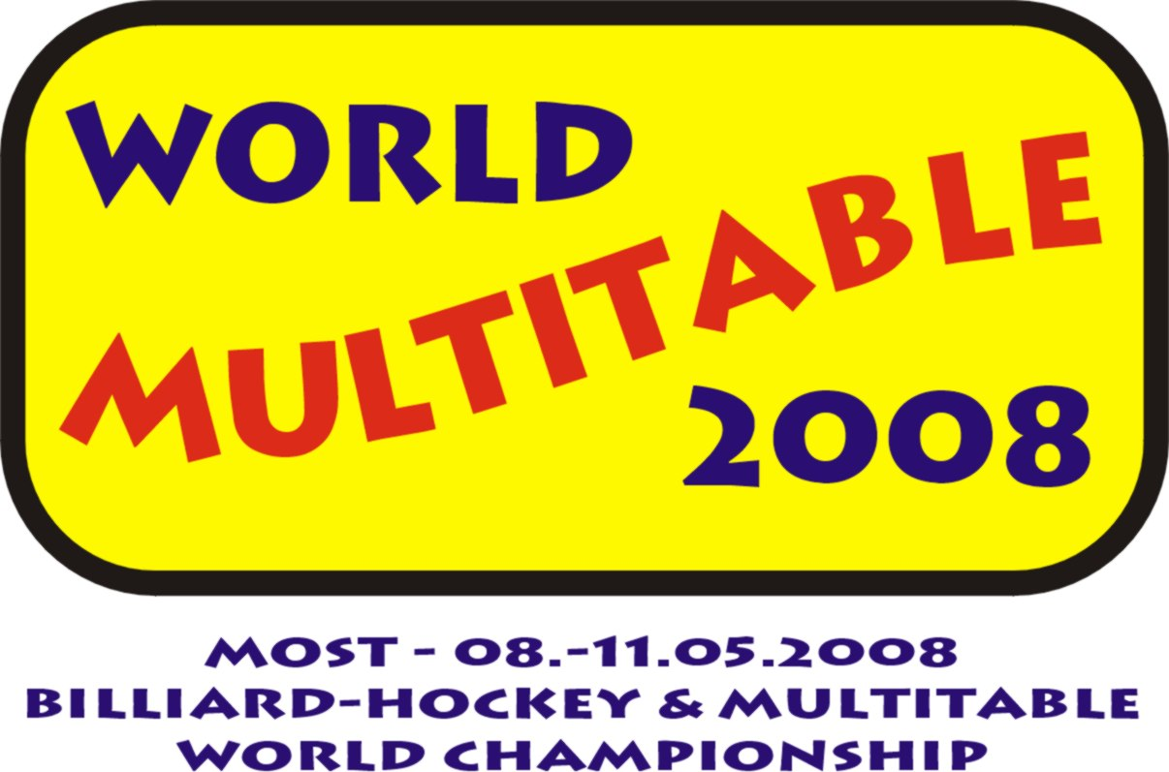

RESULTS SUMMARY – DAY III (May 10, 2008)

WORLD MULTITABLE CHAMPIONSHIP – final results

Ladies
1. VELEBOVA Nikola CZECH REPUBLIC
2. ZAUANA Magdalena NAMIBIA
3. VANOVA Lucie CZECH REPUBLIC

Men
1. HONSA Petr CZECH REPUBLIC
2. KUCERA Martin CZECH REPUBLIC
3. MACH Miloslav CZECH REPUBLIC
Juniors U 18
1. FLEISMAN Tomas CZECH REPUBLIC
2. MYKHAYLYSHYN Bohdan UKRAINE
3. KRISTIANSSON Patrik SWEDEN

United Energy CZECH OPEN – billiard-hockey

1. MACH Miloslav CZECH REPUBLIC
2. KOLODEJ Pavel CZECH REPUBLIC
3. VITAMVAS Tomas CZECH REPUBLIC

Categories
Ladies
1. BOHDALKOVA Alena CZECH REPUBLIC
Juniors U18
1. KOLODEJ Pavel CZECH REPUBLIC
Juniors U 15
1. VELEBOVA Nikola CZECH REPUBLIC
Juniors U 12
1. MULLER Ondrej CZECH REPUBLIC
Foreign participant
1. MENCL Karel SWEDEN

BAPW.CZ CZECH OPEN – air-hockey

1. VARGIN German RUSSIA
2. FALTYNEK Max CZECH REPUBLIC
3. FALTYNEK Denis CZECH REPUBLIC

Categories
Ladies
1. ZAUANA Magdalena NAMIBIA
Juniors U18
1. FALTYNEK Max CZECH REPUBLIC

