WORLD BILLIARD-HOCKEY & MULTITABLE CHAMPIONSHIP 2008

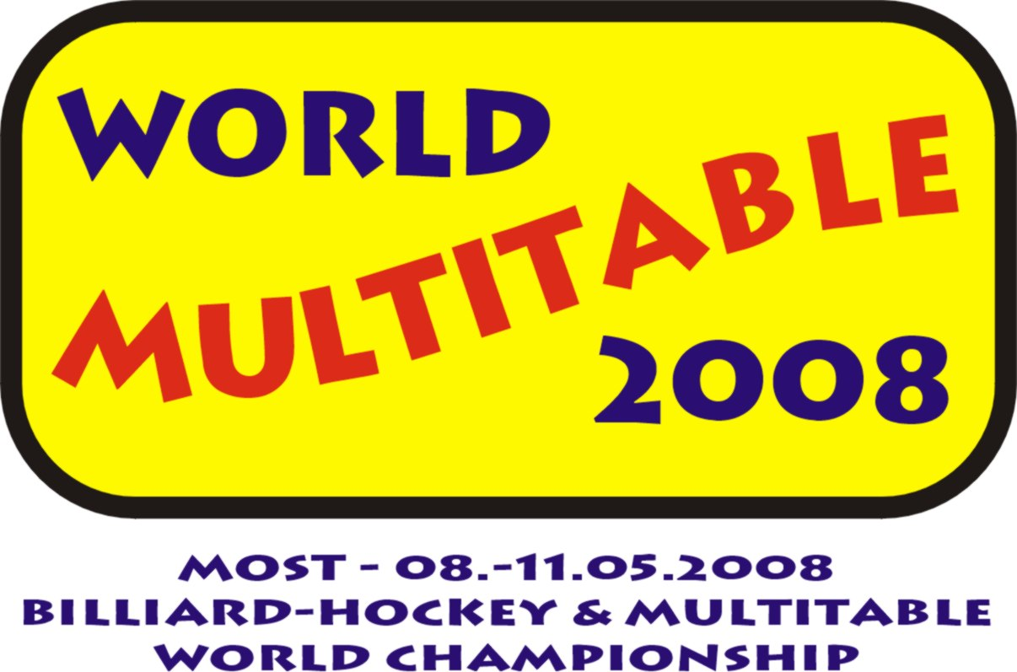

RESULTS SUMMARY – DAY IV (May 11, 2008)

Teams

Billiard-hockey (world championship & part of multitable)
1. CZECH REPUBLIC
2. SWEDEN
3. RUSSIA

Rod-hockey Luch (world championship & part of multitable)
1. RUSSIA
2. CZECH REPUBLIC
3. SWEDEN

Rod-hockey Chemoplast (world championship & part of multitable)
1. RUSSIA
2. CZECH REPUBLIC
3. SWEDEN

Rod-hockey Stiga (part of multitable)
1. SWEDEN

Air-hockey (WTHA European championship & part of multitable)
1. CZECH REPUBLIC
2. SWEDEN
3. UKRAINE

Multitable (world championship)
1. CZECH REPUBLIC
2. SWEDEN
3. RUSSIA

Associated tournaments

Air-hockey
1. FALTYNEK Denis CZECH REPUBLIC
2. LE Michal CZECH REPUBLIC
3. VELEBOVA Nikola CZECH REPUBLIC

Billiard-hockey
1. FLEISMAN Tomas CZECH REPUBLIC
2. LE Michal CZECH REPUBLIC
3. MANSSON Matti SWEDEN
Rod-hockey Chemoplast
1. CERNY Ondrej CZECH REPUBLIC
2. CERNY Vojtech CZECH REPUBLIC
3. LE Michal CZECH REPUBLIC

